Parent & Child (6 months – 2.5 years)
This program introduces babies to the water in a safe, calm, and playful environment with a parent actively involved. Sessions focus on water comfort, safety awareness, and early confidence through gentle, guided activities.
Focus areas include: water adjustment, bubble blowing and breath awareness, supported floating and basic water safety.

Toddlers
Designed to build on early water confidence, this program encourages toddlers to explore movement and independence in the water through fun, structured play. Lessons promote confidence, listening skills, and positive social interaction.
Focus areas include: breath control, supported floating, kicking movements, submersion confidence, and basic water safety.

Kidz Learn to Swim Program (Ages 3 and above)
Swimming is a life-saving skill every child deserves. At Swimlane Aquatics, our fun, play-based lessons help children build confidence, coordination, and independence in the water. In a supportive group setting, kids also learn to listen, take turns, and build friendships—making every lesson safe, engaging, and enjoyable.
During this level, we gently support children to:
- Feel safe, relaxed, and confident in the water
- Explore basic breathing skills, such as blowing bubbles and control breathing
- Gradually become comfortable floating on their front and back
- Move independently using basic kicking and arm movements
- Follow simple instructions and swim safely with others

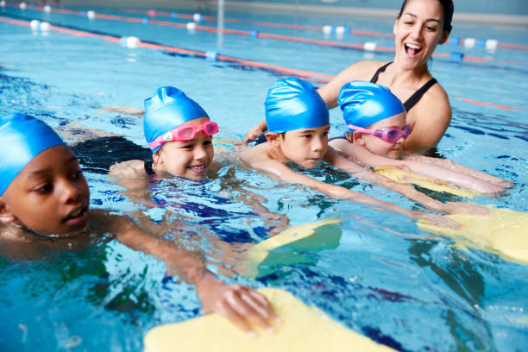

Stroke Development (Ages 3 and above)
This stage focuses on building and improving correct swimming techniques. Swimmers are guided to develop strong foundations in all strokes, with emphasis on body position, breathing, coordination, and efficiency—supporting long-term swimmer development.

Stroke Improvement (Ages 3 and above)
This stage is designed to refine and improve existing swimming skills. Instructors identify and correct technique errors, helping swimmers become more efficient, confident, and prepared for higher-level or competitive swimming in a supportive environment.

Adult Beginner Lessons
Swimming is a valuable life skill that can be learned at any age. Our adult beginner lessons are designed for comfort, confidence, and steady progress—whether you’re learning for the first time or overcoming fear of the water. Swimming is also a low-impact, full-body exercise that improves strength and fitness, making it an excellent choice for overall well-being and rehabilitation.
This level aims to help adults:
- Feel confident and relaxed in the water
- Learn basic breathing and floating
- Develop simple kicking and arm movements
- Move independently over short distances
Adult Stroke and Skill Development
This level is designed for adults who are comfortable in the water and want to improve their swimming technique. Lessons focus on refining strokes, improving breathing and body position, and building endurance. Swimmers develop efficiency, confidence, and control while swimming longer distances with better technique in a supportive environment.

Aqua Fittness unedited
Our ladies-only aqua aerobics classes offer an enjoyable and invigorating way to start your morning workout. The lively atmosphere and upbeat music make exercise both fun and energizing. The buoyancy of water reduces the impact of gravity, allowing you to perform most land-based exercises in water with minimal stress on muscles and joints. Additionally, working out in water enhances your range of motion. After just six classes, you will notice a positive change in your mood and overall well-being.

Private Classes (One-on-One Instruction)
We offer private swimming lessons for all ages and skill levels. These sessions are perfect for swimmers who want faster progress, focused attention, or customised training to meet specific goals.

